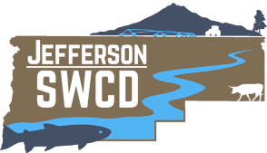

JEFFERSON COUNTY SWCD BOARD MEETING AGENDA
November 15, 2022 ~ Madras Airport Conference Room ~ GoToMeeting Option
2028 NW Berg Dr, Madras, OR 97741 ~ 12PM

Call to Order:

_____ Approve September 27, 2022 Minutes

Approve November 15, 2022 Financial Activity Report

_____ Welcome, Craig Weigand Jr.!

_____ New Website is Live! ~ Ellen and Lisa

_____ BOR WaterSMART Juniper Removal Project Update ~ Ally and Staci

_____ JCSWCD (Future) Name Change?

_____ Drought Resiliency Group; Campbell Creek SIA Monitoring Updates ~ Ellen

_____ CREP Update ~ Lisa

_____ JCSWCD Long Range Plan and Annual Report Updates ~ Lisa and Staci

Trout Creek Project Update ~ Adam

_____ MDWC Report ~ Ally

_____ PSP Strategic Plan Meeting #2 ~ Lisa

Advisor Reports

Director Reports

Public Comment

Set next meeting

Adjourn!

