Drought Resiliency for Jefferson County Agriculture (“Ag Drought Group”)
Meetings #3 = Continuation of Vision, Solutions
Monday, January 9, 2023; 2-4pm

I. Participants

Ally Steinmetz (MDWC)
Bailey Jenks (OSU Ext)
Brad Klann (JCSWCD Board & farmer)
Brent Fessler (rancher)
Cate Cassad (farmer)
Chris Gannon (CRWC)
Collin Cowsill (NUID)
Craig Weigand (JCSWCD Board & farmer)
Elaine Cornick (Culver citizen)
Ellen Hammond (JCSWCD)
Erin Kilkullen (DSWCD)
Jim McNamee (dryland rancher)
John Spring (OSU Ext)
Lisa Windom (JCSWCD)
Lisa Seales (DRC)
Mark Wunsch (rancher & County Commission)
Mike Badzmeirowski (ODA)
Rob Galyen (JCSWCD Board & farmer)
Scotty Samsel (JCSWCD Board & farmer)
Smita Mehta (DEQ)
Staci Merkt (JCSWCD)
Tom Osborne (BPA)

New Participants
Cate Casad = Casad Family Farms (“regenerative” pasture-raised meat)
Bailey Jenks = OSU Extension (specialty is wheat)

II. New data from COAREC
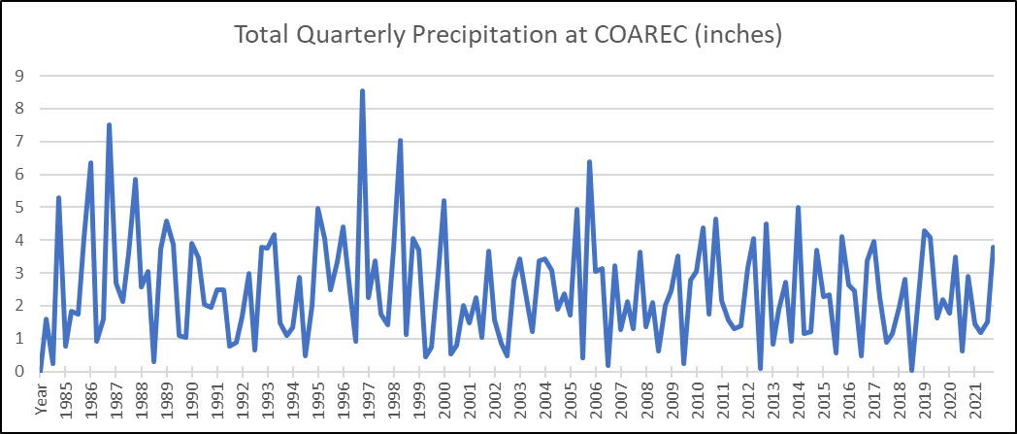
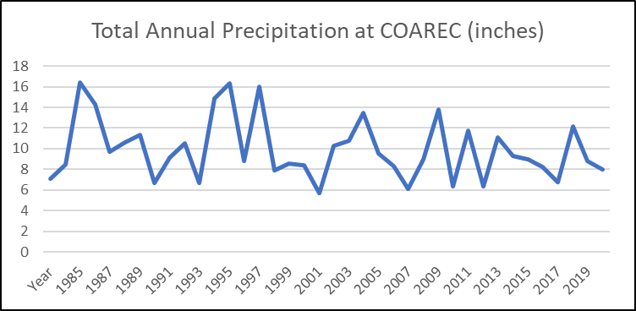
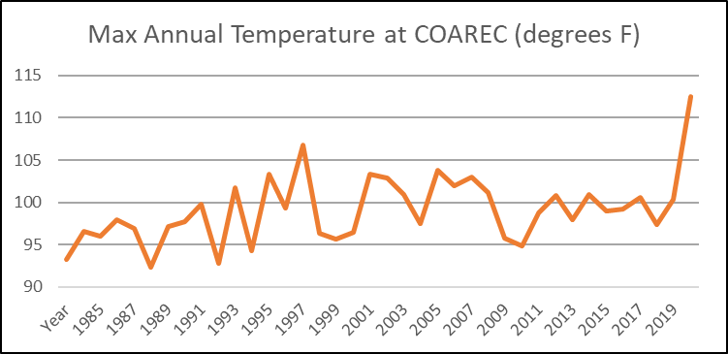
Due to questions about the source of data Ellen provided at the first meeting for temperature and precipitation trends in Jefferson County for 125 years, Ellen found data back to 1983 collected at the Central Oregon Ag Research and Extension Center (COAREC).

III. Vision and Mission Statements
This group needs to show clearly how they are different from other groups working on similar issues. This group is specifically addressing the following:
- Agriculture drives Jefferson County culture, economy, and land conditions
- Temperatures are likely to keep rising while precipitation decreases and becomes more erratic
- JeffCo agriculture needs additional tools to stay viable

The Group was provided with 3 versions of the Vision, of which they selected one and began wordsmithing it. The red text needs to be revisited.
“Jefferson County agriculture is resilient (thrives), supporting its people, animals, economy, environment, and culture through collaboration with Deschutes Basin stakeholders”.

Then Craig W proposed the following Mission:
“Mission: To protect, highlight and preserve JeffCo agriculture and natural resources through education, reciprocity, partnerships and trust with Deschutes Basin stakeholders.”

Mike B proposed the following
"Our vision is to create a sustainable, livable future for the residents and agricultural stakeholders of Jefferson County by proactively addressing the impacts of aridification and promoting the efficient use of water resources. Through innovative solutions and partnerships, we will ensure that our community is resilient in the face of a changing climate and able to adapt to increasingly dry conditions.”

Some comments from the Group: ADD SOMETHING ABOUT DROUGHT. Add something about adapting/evolving, not just preserve, in the face of changing circumstances.

Wordsmithing with a large group is inefficient, so Ellen suggested the Group move on to the ‘Solutions’ part of the agenda and wordsmithing would be done before the next meeting with options provided to the Group for further improvement.

IV. Adopton of Innovation
Ellen showed the following chart that is applicable to all kinds of activities, including farming. In addition, a second chart shows the gap that must be bridged to get most of the target audience to adopt a specified action.
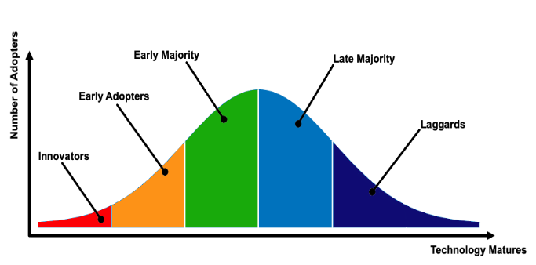
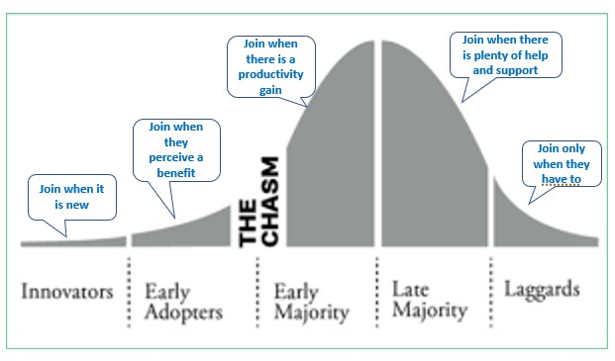

V. Continue identifying solutions, especially related to actions landowners can take
This conversation covered a lot of ground, so these notes are an attempt to organize the wide-ranging discussion. The Group includes landowners who are Innovators and Early Adopters for this area.

JeffCo’s climate, including short growing season, is ideal for growing seed crops, not as good for growing forage. JeffCo soils are shallow and naturally low in organic matter; irrigation has increased soil organic matter.
- Potential landowner actions
  - Diversify operations
  - Raise other crops/animals that use less water and/or are value-added
  - Raise cash crops on part of the acreage; use rest of acreage for other cropping/livestock/etc.
  - Reduce input costs: seed, fertilizer, tillage, labor, etc.
  - Transition land to organic via three years of fallow
  - Use cover crops as part of a rotation. Cover crops increase water holding capacity, reduce erosion, suppress weeds, and can improve soil health. For instance, winter cereal cover crops are great for managing weeds.
  - Graze cover crops to recycle nutrients. A mix of species, especially including pulses, in the cover crop creates better forage
  - ‘Stack industries’ e.g., run cattle on cropland some of the time and sell grass-fed meat
  - Sileage crops for livestock feed.
  - Drill seeds into crop residue (can help seed emergence, shade soil, and ??)
- Challenges
  - Several Group farmers have tried alternative crops such as garbanzo beans, but there is no processor close enough, resulting in expensive transportation costs.
  - Some of these alternative crops occupy such a small niche that it is hard to get enough yield to build a processing plant or market them
  - Is there enough rainfall to support economically viable cover-cropping, or do they need to be irrigated?
  - Irrigating less will reduce soil organic matter.
  - Need a source of cost-effective seed for cover crops or alternative cash crops
  - High value seed crops need clean fields and seed. Challenge to keep the fields clean when using cover crops
  - Creating sileage takes water and diesel to haul
  - Farmers operate on a small margin; it is risky to commit to new crops when water is unpredictable
  - Teff needs to get planted later in the year (June), so requires irrigation
  - Grazing cover crops requires a livestock water source, fencing, livestock, and livestock transportation. The irrigated fields are not readily set up for this. In addition, there is concern that cattle will compact the soil on Agency Plains and that seed inspectors want to see seed in rows; rows disturbed by cattle could move plants to the side and appear as ‘off-types’ to certifiers
  - Monoculture winter wheat is desirable for farmers because 1) can be harvested for grain if it receives enough moisture, 2) fewer types of weeds for growers of seed cash crops to control, and 3) covered by crop insurance.
  - Barley as a cover crop can harm subsequent carrot crop
- Helpful things
  - Research drilling into bluegrass seed plants; bluegrass roots put a lot of organic matter into the soil (their roots are up to 18” long)
  - Research alternative crops and cropping/livestock systems that could do well here
  - Research marketing options
  - Research opportunities for developing processing infrastructure, such as oils. Joining with neighboring dryland farmers in Sherman and Wasco counties might create a large enough yield to make it worthwhile
  - Work with seed processors to support alternative seed crops
  - Figure out what to measure to show success
  - Increase outreach to farmers about soil organic matter
  - Experiment with barley hay
  - Figure out how to get info to Innovators/Early Adopters and also how to encourage the rest
V. Upcoming meetings: 1st Monday 1-3pm with snacks

