Greetings Friends and Colleagues,

As some of you may know, in December of 2021 the Oregon State Legislature awarded funds to OSU Extension to identify what practices farmers and ranchers are using to deal with drought and heat pressures, and what types of support they would like moving forward. We are contacting you today to humbly request your participation in this effort.

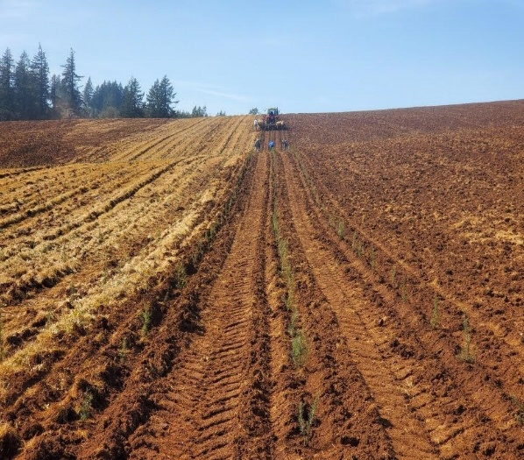
Who: Any individuals actively farming in the state of Oregon who are concerned about, or are currently contending with, drought and heat pressures on-farm.

What to Expect: A brief (30 to 40 minutes) interview regarding your on-farm practices, strategies, and resource needs in relation to drought and heat mitigation. Interviews will be recorded, but the data will be anonymized prior to inclusion in the report. You may also opt to withdraw your participation at any point. Interviews may be done in-person (depending on location), via Zoom, or by phone depending on your preference.

Benefits: Your input will help guide the state legislature in enacting real-world policy measures and directing future research and funding to provide meaningful resources to Oregon agriculturalists.

To participate in this initiative, please use this link to schedule an interview. If you have any questions or concerns, please email us at nelsenb@oregonstate.edu.
We offer you our sincere thanks in advance for your time and input and look forward to working with you.

Sincerely,
Berit Nelsen, Maria Zamora Re, and Abigail Tomasek

